Excel Assignment 4

# What is the benefit of Microsoft 365?

# Office 365 **lets you share mailboxes, calendars, contacts and edit documents in real time through collaborative tools**. Sharing calendars in Exchange means you can see who in your organisation is available when, so you can schedule meetings that work for everyone, first time round.

## You’ll always be secure in Office

# Many people still have the impression that the cloud isn’t secure. But this isn’t the case. If anything, it’s more secure, if your cloud environment is built correctly. It’s all about how you use the features available and what security measures you put in place. Some of the security features you can benefit from in Office 365 are:

## Message encryption, which enables you to send encrypted emails that will not allow anyone other than the recipient to open them.

## Advanced Threat Analytics will allow you to identify any suspicious activity in real time, reducing the risk of any damage. This will empower your business to quickly detect any threats, reduce false positive fatigue and easily plan your next steps to protect your business from any suspicious activity.

## Mobile Device Management allows you to manage Office 365 on your employees’ mobile devices. Within this feature, you can manage device security policies, view device reports and can remotely wipe a device if it’s ever stolen.

# Data Loss Prevention helps prevent any sensitive information from leaving your organisation. DLP will help you identify, monitor and protect any sensitive information in your Office 365. When DLP is enabled it will scan for sensitive information e.g. credit card details, passport information or social security numbers.

# 2.Use two datasets and perform join on specific columns.

A. **Combine tables in Excel by column headers**

1. On your Excel ribbon, go to the Ablebits tab > Merge group, and click the Combine Sheets button:
2. Select all the worksheets you want to merge into one. ...
3. Choose the columns you want to combine, Order ID and Seller in this example:
4. Select additional options, if needed.
5. You can merge (combine) rows from one table into another simply by pasting the data in the first empty cells below the target table. The table will increase in size to include the new rows. If the rows in both tables match up, you can merge the columns of one table with another—by pasting them in the first empty cells to the right of the table. In this case also, the table will increase to accommodate the new columns.
6. Merging rows is actually quite simple, but merging columns can be tricky if the rows of one table don't correspond with the rows in the other table. By using , you can avoid some of the alignment problems.

## **Merge two tables using the VLOOKUP function**

1. In the example shown below, you'll see to new names: "Blue" and "Orange." In the Blue table, each row is a line item for an order. So, Order ID 20050 has two items, Order ID 20051 has one item, Order ID 20052 has three items, and so on. We want to merge the Sales ID and Region columns with the Blue table, based on matching values in the Order ID columns of the Orange table.
2. Order ID values repeat in the Blue table, but Order ID values in the Orange table are unique. If we were to simply copy-and-paste the data from the Orange table, the Sales ID and Region values for the second line item of order 20050 would be off by one row, which would change the values in the new columns in the Blue table.
3. Here's the data for the Blue table, which you can copy into a blank worksheet. After you paste it into the worksheet, press Ctrl+T to convert it into a table, and then  Blue.

# How to perform string formatting in excel.

# A. Right-click any cell and select Format Cell.

# On the Number format tab, select the formatting you need.

# Select Custom from the Category list on the left of the Number Format dialog box.

# Copy the syntax found in the Type input box.

## Syntax

The syntax for the FORMAT function in Microsoft Excel is:

Format ( expression, [ format ] )

### **Parameters or Arguments**

**expression**

The string value to format.

**format**

Optional. It is the format to apply to the expression. You can either define your own format or use one of the named formats



# 3.Create reports to generate mark sheets of students in excel where percentages and addition of marks should be done using formulas.

Marksheet Calculation in Excel



Sr Subject Total Marks Obtain Marks Grade IF formula for Grade

1 English 100 81 A =IF(D5<35,"F",IF(D5<60,"C",IF(D5<80,"B","A")))

2 Math 100 75 B =IF(D6<35,"F",IF(D6<60,"C",IF(D6<80,"B","A")))

3 Science 100 60 B =IF(D7<35,"F",IF(D7<60,"C",IF(D7<80,"B","A")))

4 Physics 100 55 C =IF(D8<35,"F",IF(D8<60,"C",IF(D8<80,"B","A")))

5 Chemestry 100 30 F =IF(D9<35,"F",IF(D9<60,"C",IF(D9<80,"B","A")))

6 Evs 100 80 A =IF(D10<35,"F",IF(D10<60,"C",IF(D10<80,"B","A")))

Total 600 381 =SUM(D5:D10)

Grade Criteria

Above 80 A Minimum 30.00 =MIN(E5:E10)

60-79 B Maximum 81.00 =MAX(E5:E10)

35-59 C Average 63.50 =AVERAGE(E5:E10)

0 - 34 F Percentage 63.50% =E11/D11 Cell format Percentage

**Excel to calculate percentage : =E10/D10  ( Cel**



[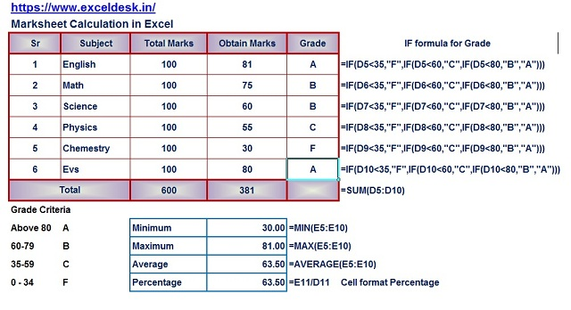](https://1.bp.blogspot.com/-VjKad3McTEM/XcWjeBUL3sI/AAAAAAAAC8I/c5QtRTooEU8RuKAnVhPJmOAyKzjoAzaOACLcBGAsYHQ/s1600/Marksheet.jpg)

